This document contains images of the artist’s work that did not make it into the demo.

Tabel of Contents

1.0. Concept Art 2

*1.1. Biomes that did not end up in the demo* 2

*1.2. Ghosts types that did not end up in the demo* 3

*1.3. Sand shark enemy* 3

2.0. 3D Models 4

*2.1. Machines* 4

*2.2. Early iterations of chests* 4

*2.3. Large chest* 5

*2.4. Drill* 5

*2.5. Spotlights* 5

*2.6. Resources* 6

*2.7. Plants* 6

# 1.0. Concept Art

## *1.1. Biomes that did not end up in the demo*

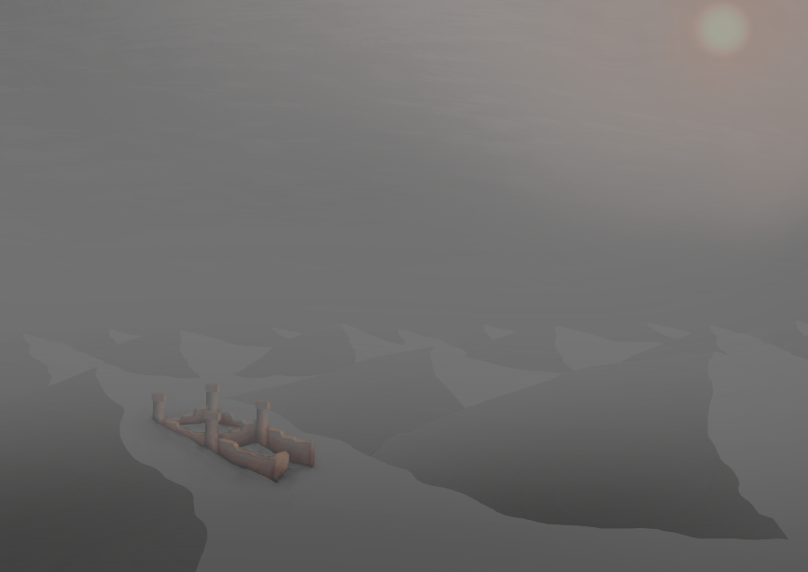

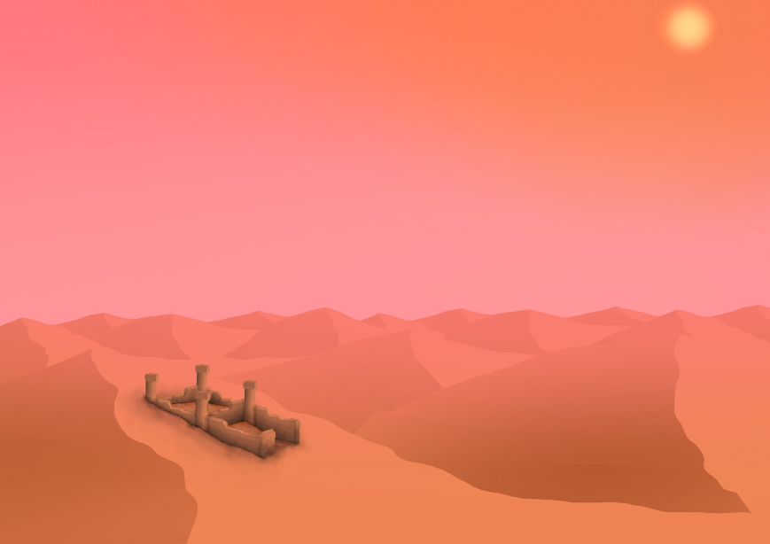

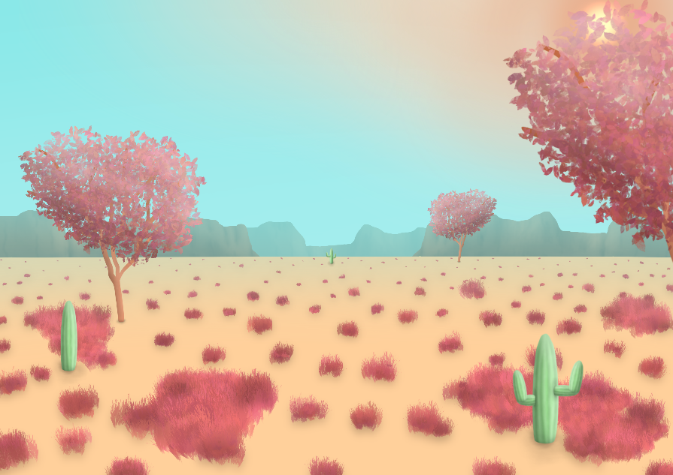

## *1.2. Ghosts types that did not end up in the demo*

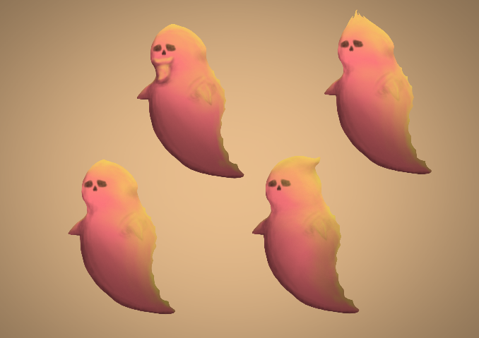 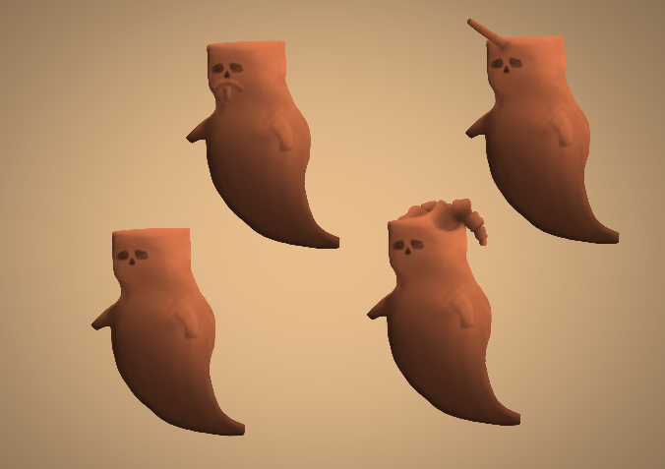

## *A cartoon shark on a tan background Description automatically generated1.3. Sand shark enemy*

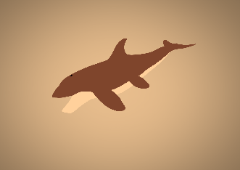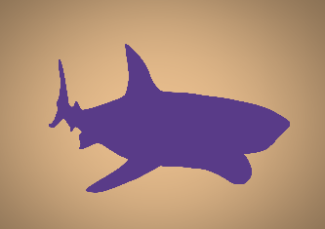

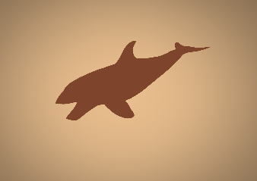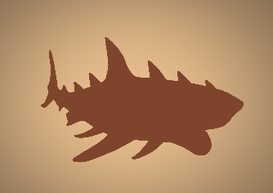

# 2.0. 3D Models

## *2.1. Machines*

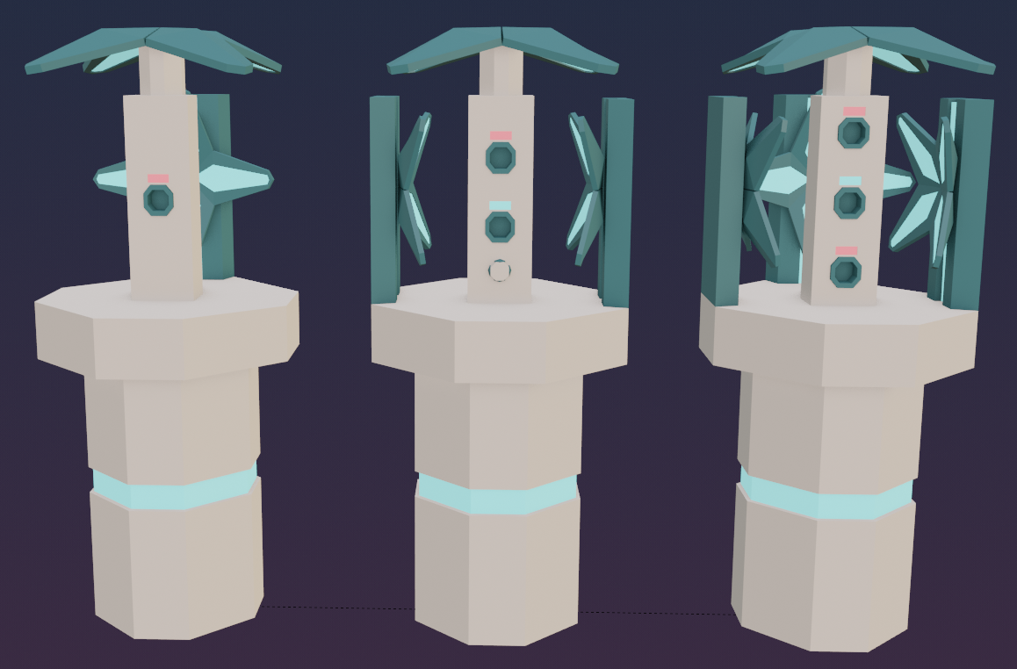 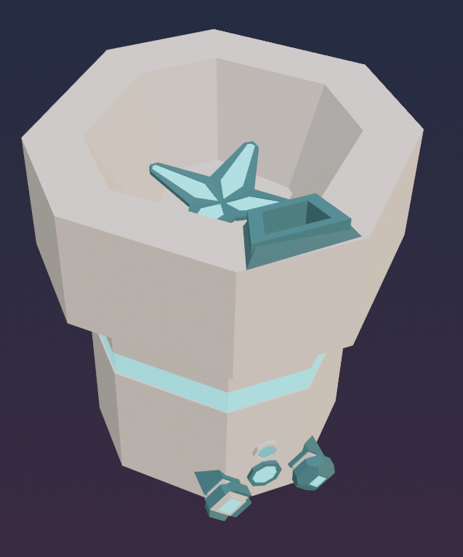 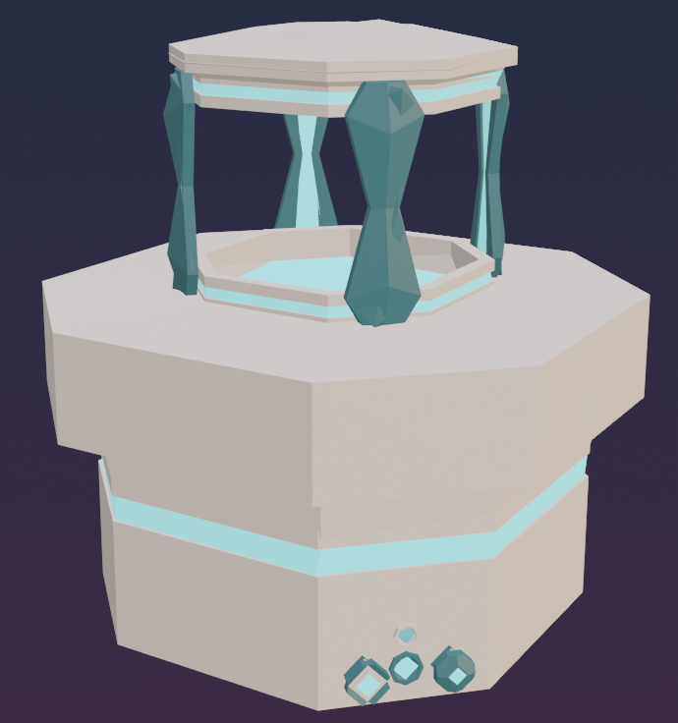

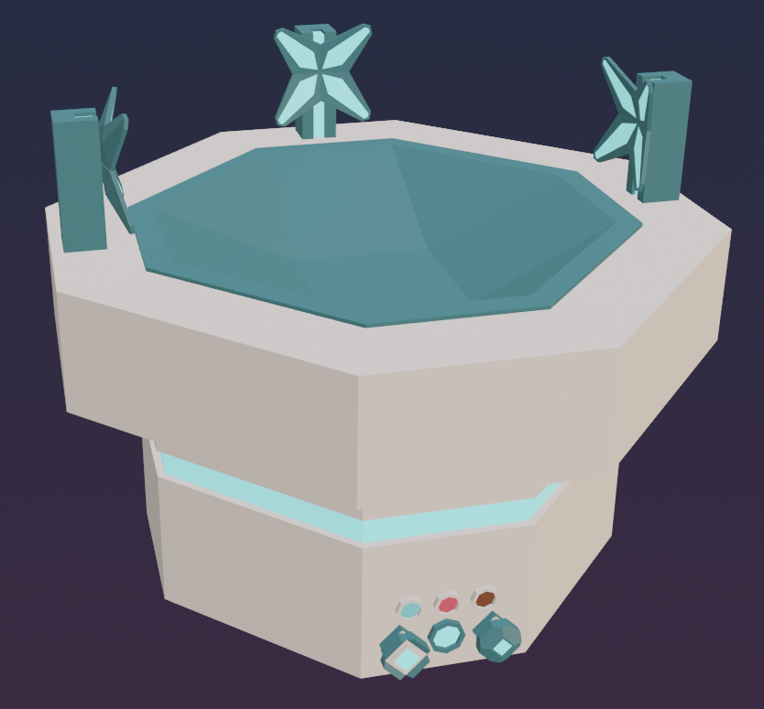 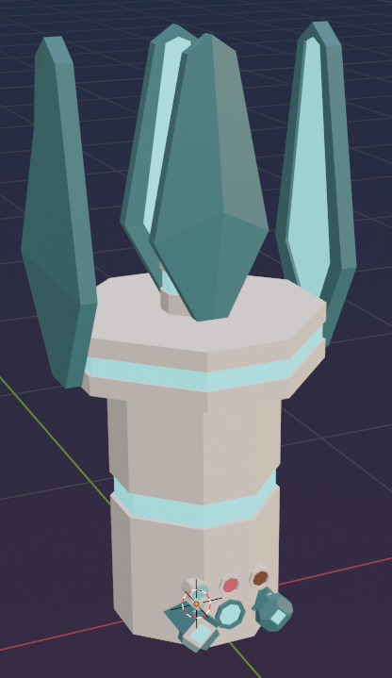 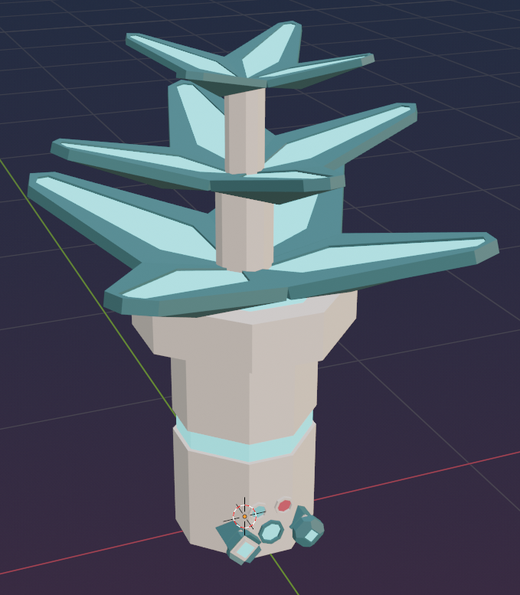 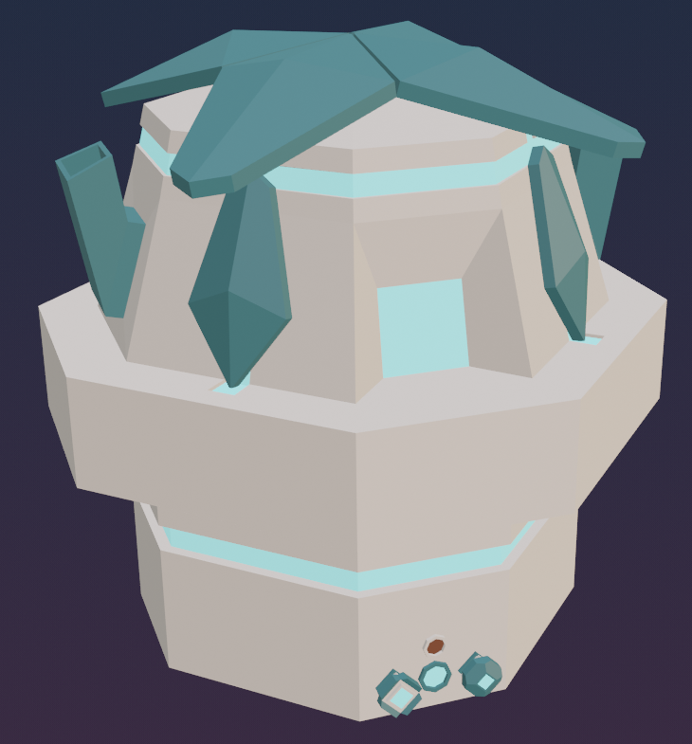

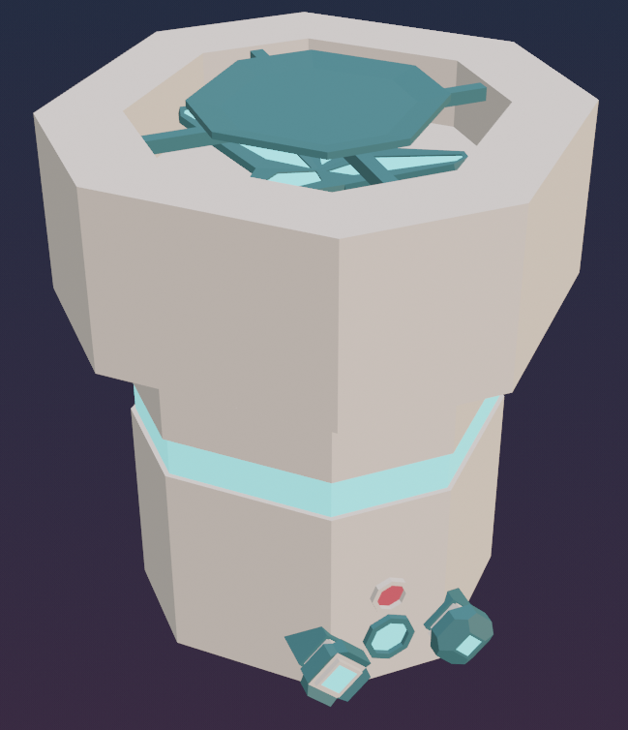 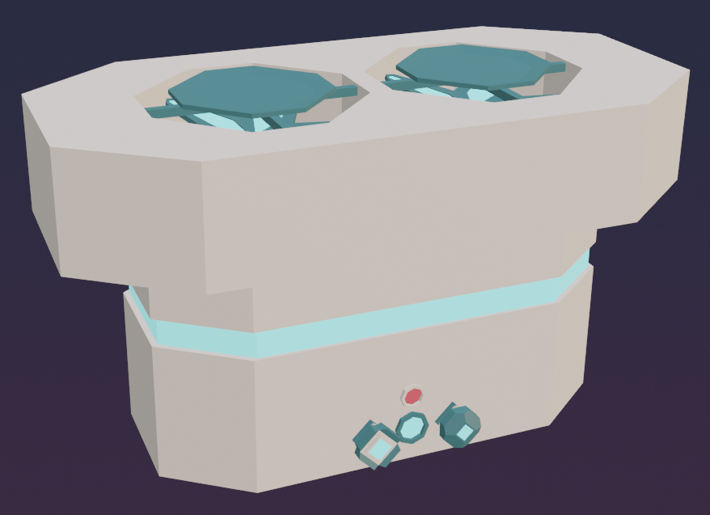 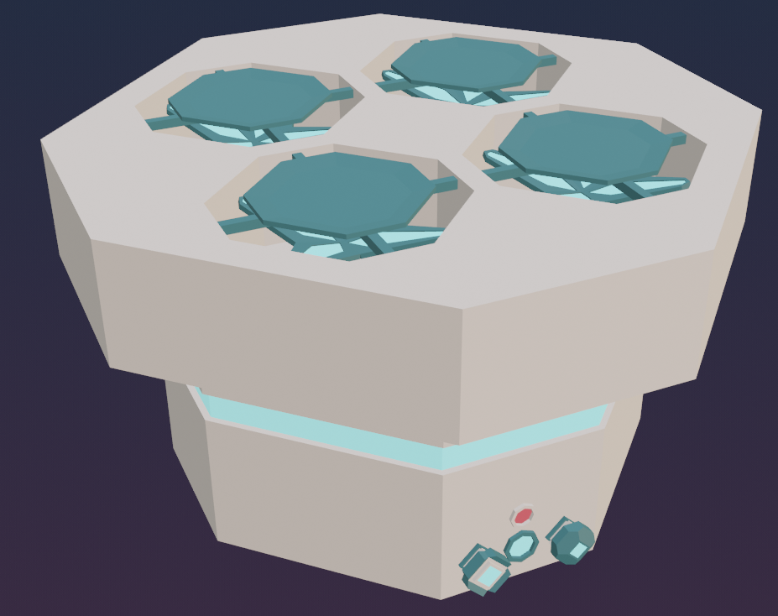

## *2.2. Early iterations of chests*

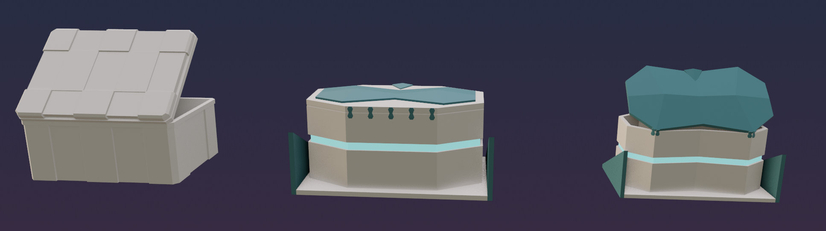

## *2.3. Large chest*

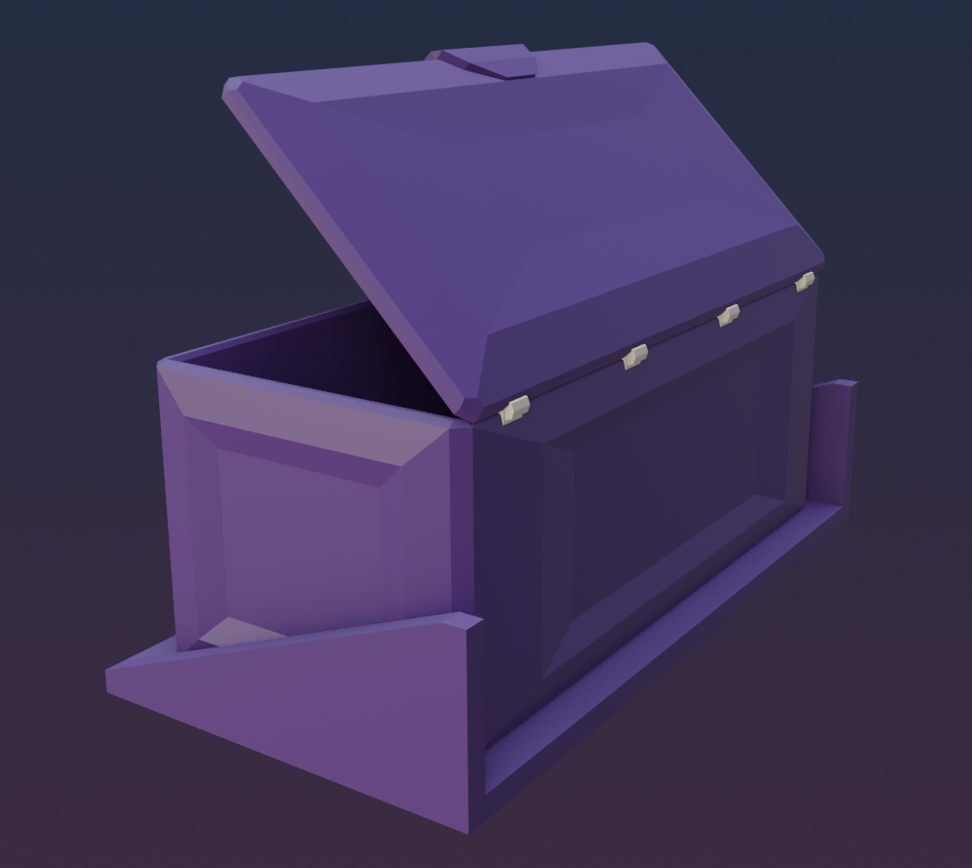

## *2.4. Drill*

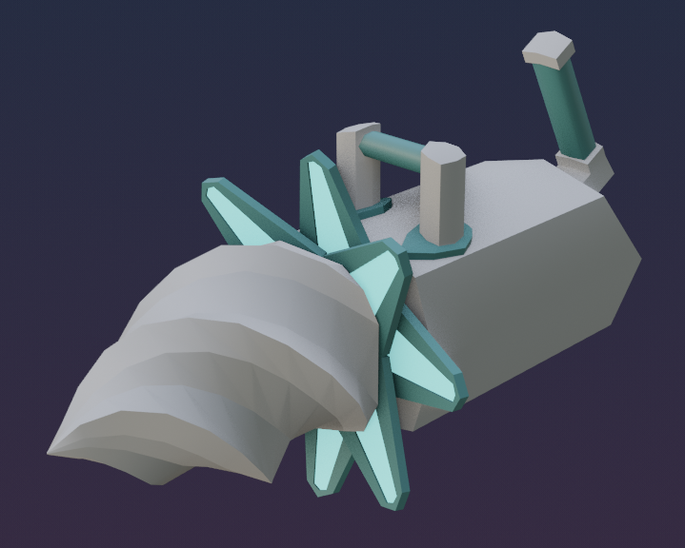

## *2.5. Spotlights*

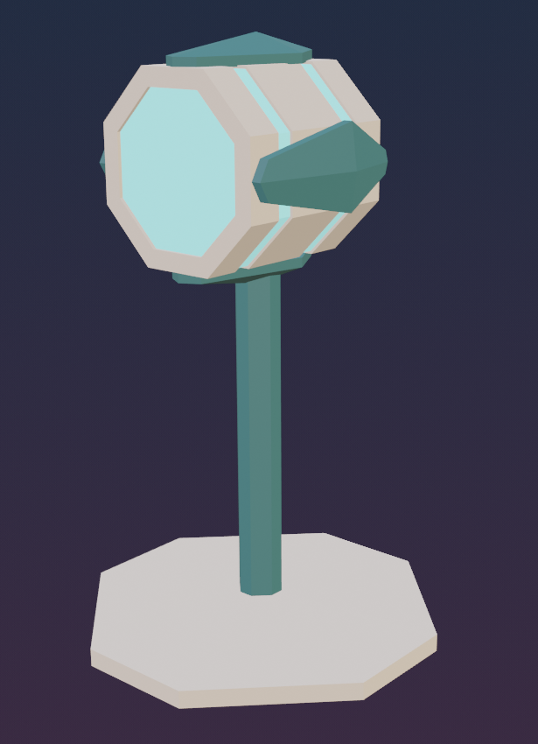 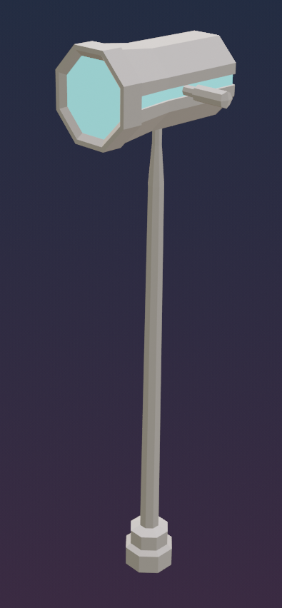 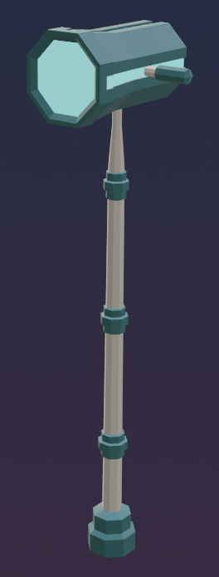

## *2.6. Resources*

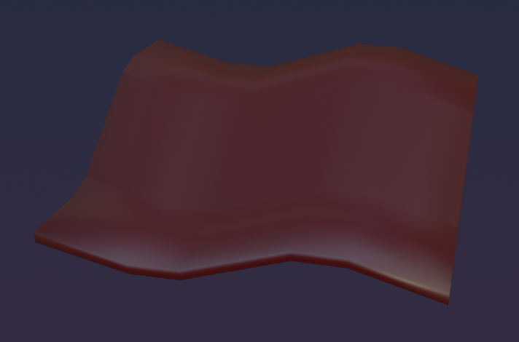 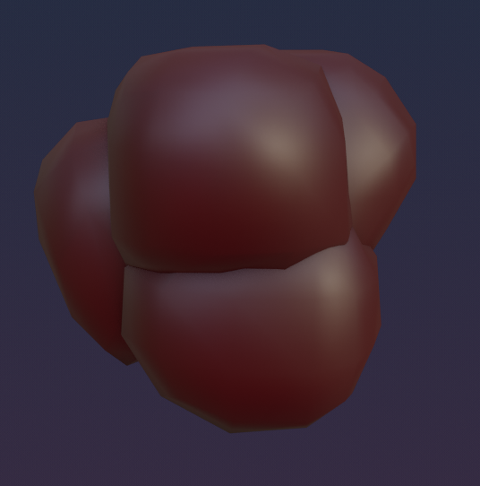

## *2.7. Plants*

